HEALY-MURPHY CENTER
Annual Report
2019-2020 Academic Year

618 Live Oak San Antonio, TX 78202
(210) 223-2944 www.healymurphy.org

In the 2018-2019 school year:

36 students earned their high school diploma.

32 students earned their high school equivalency.

16 children graduated from pre-k physically, socially, and emotionally ready for school.

96% of all infants and toddlers served met or exceeded all performance indicators as measured by the Early Learning Assessment profile.

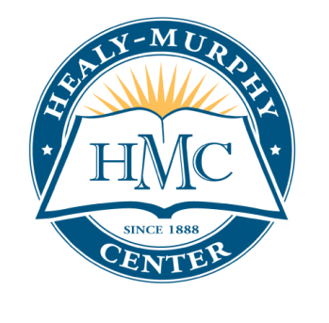
MISSION STATEMENT:
Healy-Murphy Center provides compassionate service to youth-in-crisis by focusing on individualized education in a non-traditional high school setting, early childhood development, and essential support services.
CLIENTS SERVED
- High school serves approximately 350 students per year
- Approximately 27% of teen students are pregnant, parenting
- 74% Hispanic, 22% African American, 4% Anglo
- 100% of students qualify for free or reduced meals; 37% of
- high school students are homeless
- Child Development Center served 175 children per year
- Children served are those of the high school students and
other families struggling with poverty
SERVICES PROVIDED
- Self-paced, alternative educational environment
- Accredited high school academic classes and GED classes
- Child Development Center –Texas Rising Star Provider
- Health clinic for pre- and post-natal exams and childhood immunizations, emergency services, health education and referral to health care services
- Mental health counseling and support groups
- Case management
- Parenting and childbirth classes
- Vocational counseling and job placement assistance

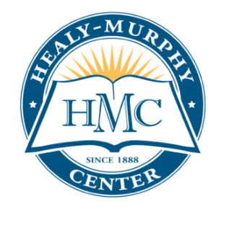
HEALY-MURPHY CENTER
Board of Directors

Sister Geraldine Klein, SHSp
Board President
General Superior, Sisters of the Holy Spirit

Katherine Elaine De Los Santos
Board Vice President
USAA

Sr. Mildred Gordon
Board Secretary
Sisters of the Holy Spirit

Mark Swensen
Board Treasurer
Valero

Serena Hanor Aldrich
Aldrich Law Firm, PLLC

Alexander Baez, MBA
Baez Sanchez Consulting

Phillip Mark Carter
NuStar Energy

Katherine Elaine De Los Santos
USAA

Michael E. Black, MBA
UT Health San Antonio

Patricia Garcia
Regions Bank-San Antonio

Francisco Gónima
Arquero Consulting, LLC

Donn Greiner
Telecommunications Consultant

Hon. Irene Rios
Fourth Court of Appeals

Chief Justice (Ret.) Alma L. López

Phillip Rosenfield
Frost Bank

Dr. George A. Williams, Jr.
Our Lady of the Lake University

Community Volunteer
In 2018-2019, 100% of board members contributed financially to Healy-Murphy Center.

United Way | 378,484
City of San Antonio Youth Training Project | 319,639
Early Head Start | 457,124
USDA Food Program | 163,925
Program Service Fees | 131,546
Foundations and General Contributions | 531,852
In-Kind services | 700,627
Other Fees | 183,363
Interest and Investment Earnings | 168,358
Gain (Loss)/Other Revenues | 69,906
Capital Campaign | 3,862,505
TOTAL REVENUES, GAINS & SUPPORT | 6,903,427

Consolidated financial statements for the year ended September 30, 2018 audited by Armstrong, Vaughan & Associates.

Program Services | 3,123,730
Supporting Services, Management and General | 156,227
Fundraising | 65,467
TOTAL EXPENSES | 3,345,424

TOTAL NET ASSETS FY 2018: $6,442,805

Consolidated financial statements for the year ended September 30, 2018 audited by Armstrong, Vaughan & Associates.

